Ubuntu running
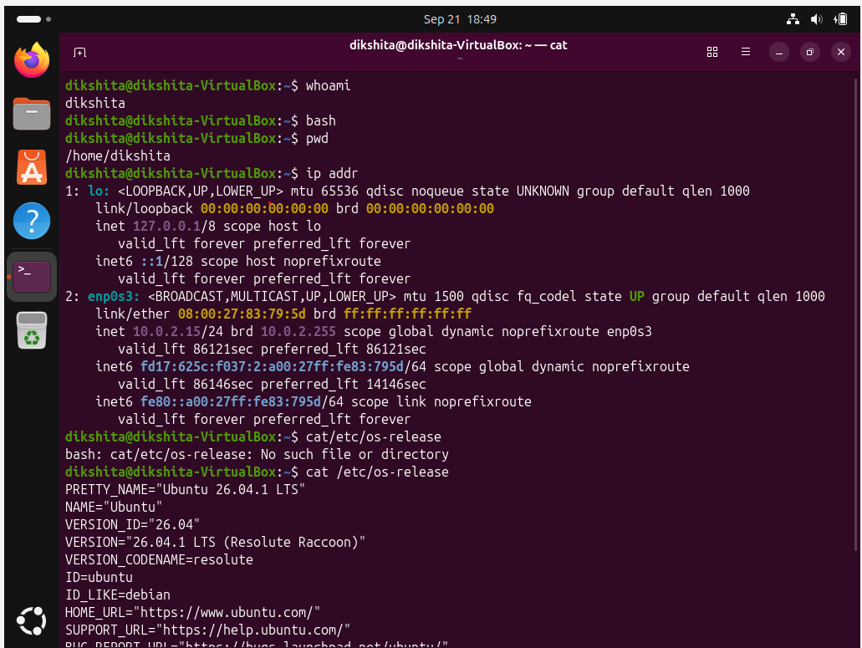
Commands
Filesystem navigation:
PWD : Print working Directory – Displays the path of the current directory.
Ls : Lists all the items within the directory.
Echo : More like the print command , takes input from user and displays as output.
Cd : change directory.
Cd . = current directory
Cd .. = One level up to the directory containing your current one.
Cd - = Takes you to previous directory
Cd ~ = Shortcut to personal home directory
mkdir : Create a new directory.
Touch : Create new empty text files.
Cp : copies a file/directory from one location to another.
Mv : Move the content of 1 file to another file ( also automatically deletes the primary file). - moves or renames a file/directory.
Rm : Remove or delete text files.
Rmdir : Remove / delete directory.

Viewing files:
Cat : Displays the data in the file
Less : Read files scrolling through the terminal
Head : Preview the beginning of the file (first 10 lines by default)
Tail : Displays last part of a file ( by default last 10 lines)

Search and filtering
Grep : Search particular strings.

Users and permissions
Chmod : Change file permissions
Chown : Changes the owner of the file.

Processes
ps : Shows the processes currently running for your session
top : Shows running processes live, along with CPU and memory usage

System resources
free -m : displays used, free, and available memory.
Df -h : Shows disk/storage usage in an easy-to-read format

Services
systemctl status nginx
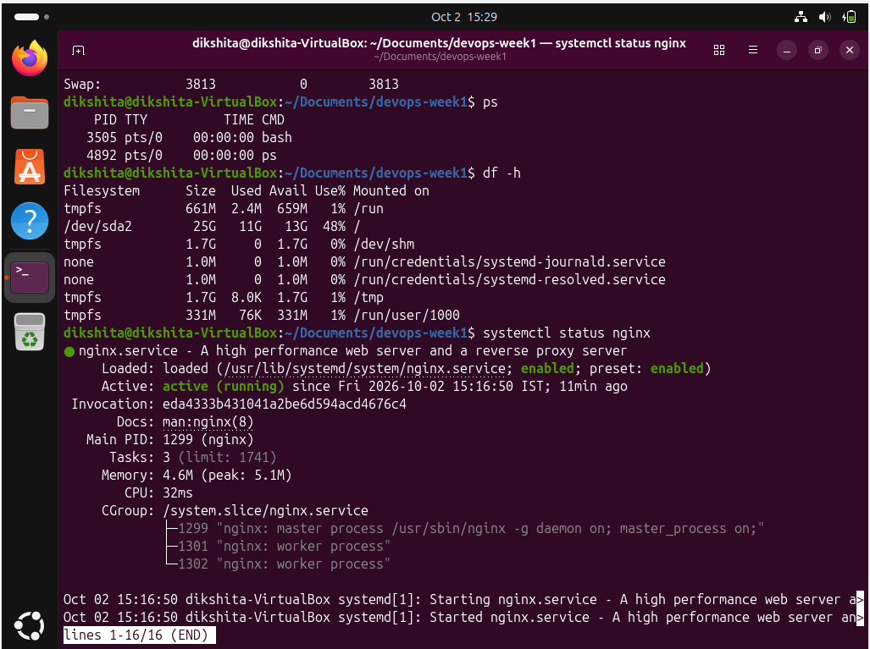
Systemctl stop nginx – Without sudo it will ask for the user authentication
So sudo systemctl stop nginx is used.
Command | Meaning

sudo systemctl start nginx | Starts Nginx if it is stopped

sudo systemctl restart nginx | Stops Nginx and starts it again
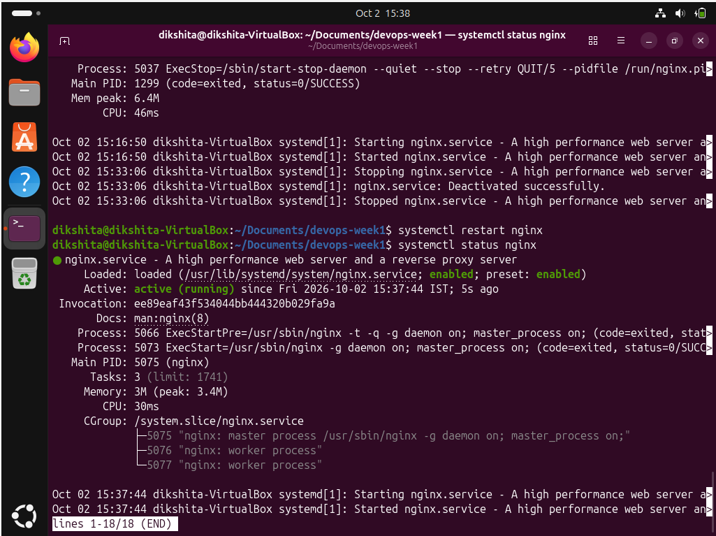

Journalctl : journalctl is another command used to view logs collected by systemd.
systemd = the actual system/service manager
systemctl = the command-line tool used to communicate with systemd
nginx = the service we are managing
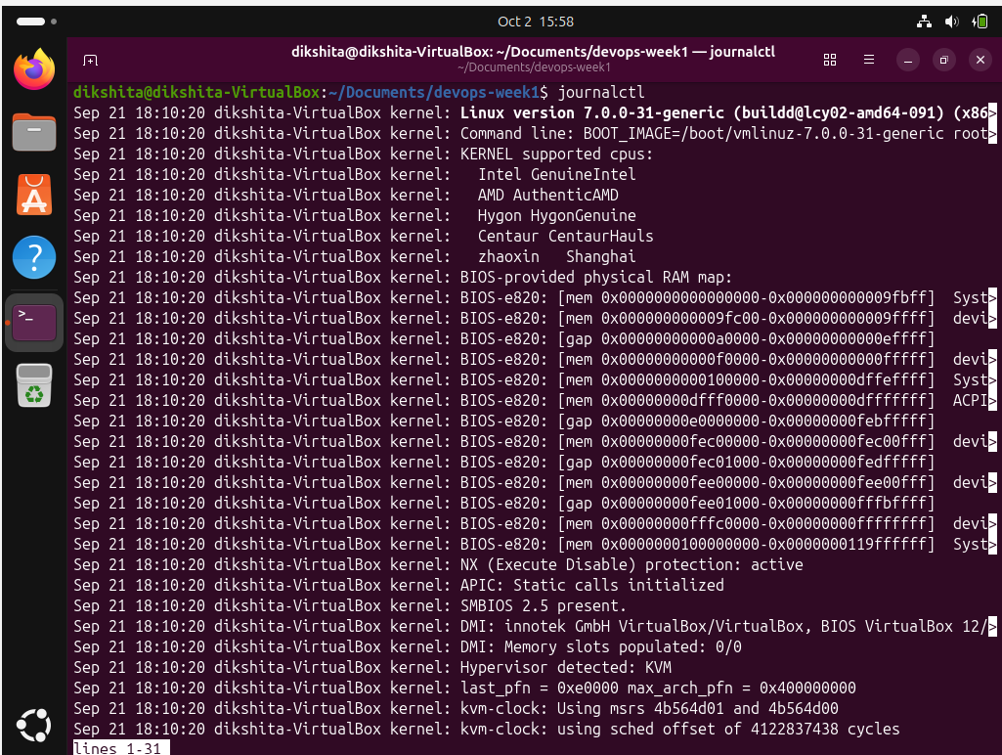
Ports and listening services
Ss -tulnp :
-t = TCP
-u = UDP
-l = Listening
-n = Numbers
-p = Process
tcp LISTEN ... 0.0.0.0:80
tcp LISTEN ... [::]:80
Port 80 is listening, which means Nginx is listening for HTTP connections on your Ubuntu machine.
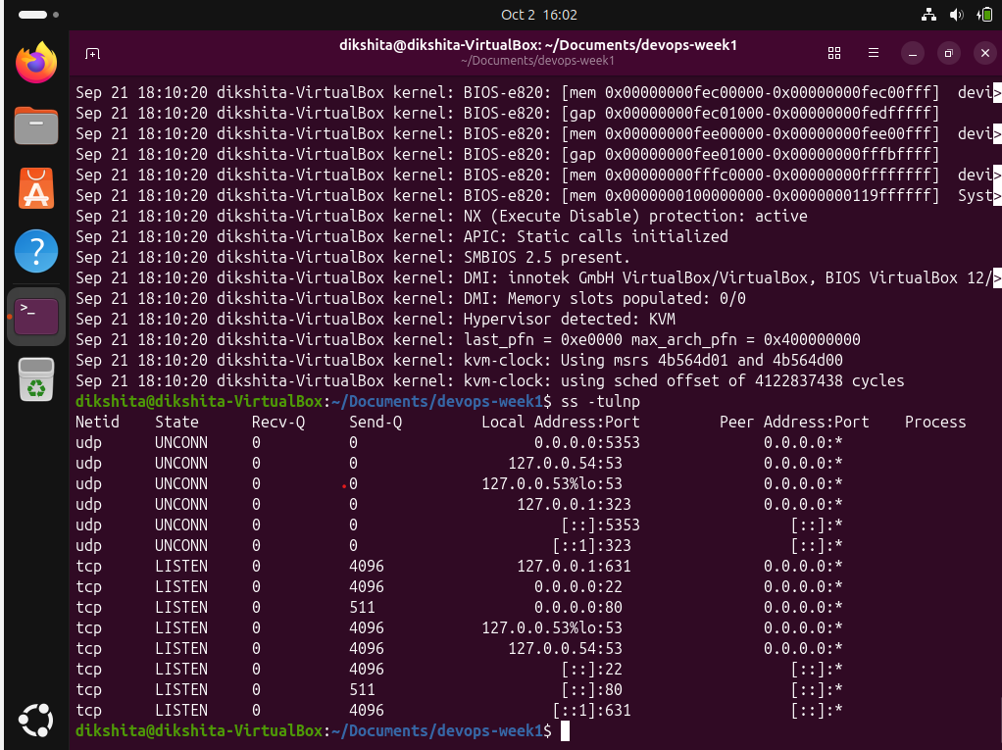
Basic HTTP testing
Curl:curl is a command-line tool used to send a request to a web server.
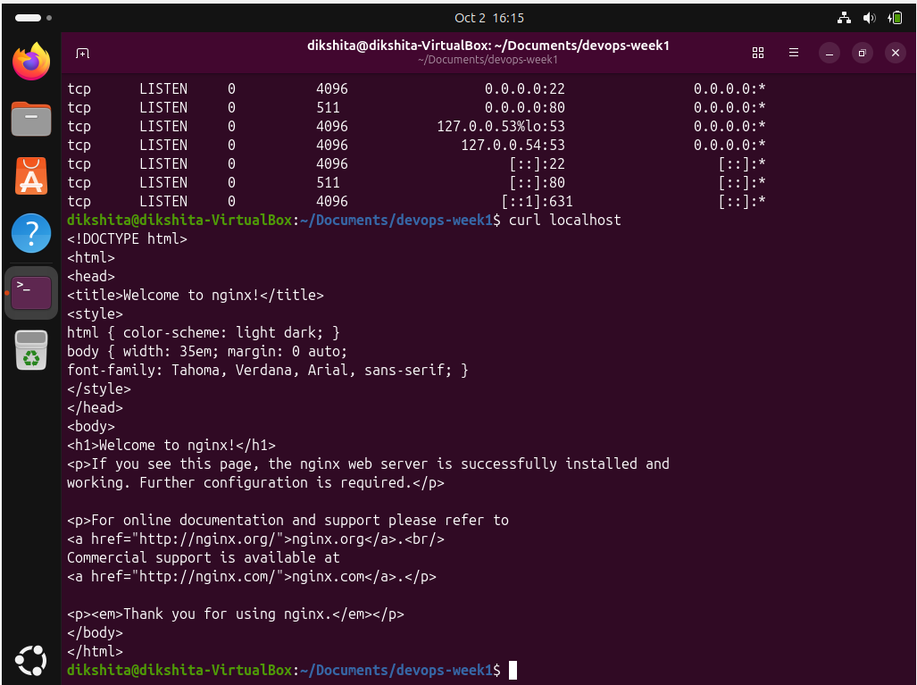
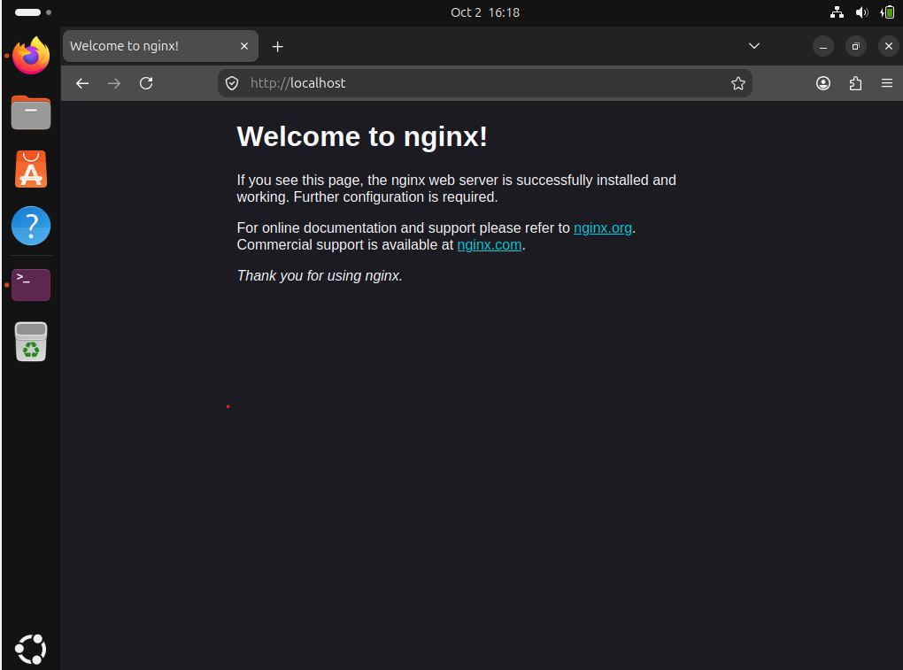 a

